1. **INTRODUCTION**

In modern era the numbers of house hold electric appliances used are increasing day by day with the advent of new and modern technology. So the consumption of electricity has rapidly increased from the past few years. All commercial users are found to be using more electricity during same period leading to electricity demand peaks at same instant of time. So the electricity usage has been increasing rapidly but the generation has not been increased and as a result we face power outages. Due to this reason consumers are diverting to costly and alternative methods to meet their required demand.

Consumers are opting for other alternative sources such as diesel generators. The fuel cost of such alternative sources is costly and this effects the customer billing all the way. So energy must be used in a distributed way. This can be done by investigating how to reduce demand peaks by spreading electricity consumption over time.

A new Even Driven Methodology is used to schedule the consumption of home appliances. The objective is to make sure that electricity consumption does not exceed the maximum limit during peak hours. The maximum consumption can be adjusted based on number of conditions such as number of appliances, number of users. According to event driven scheduling algorithm appliances are classified into priority classes and their operation is influenced by a controller. This methodology is to regulate the demand peaks at peak hours by continuously monitoring the loads at demand side. Customers not exceeding the maximum may have the advantage of lower rates on their electricity bills.

1. **LITERATURE SURVEY**

**Georgios Kararas** presents a novel for regulating electricity demand peaks for home appliances using reversible fair scheduling algorithm originally developed for telecommunication networks. According to band width demand and priority classes, the reversible fair scheduling algorithm delays some appliances and prolongs their operation. In this way it is guaranteed that power consumption does not exceed the maximum limit. In this paper the parameters of reversible fair smart grids. This paper presented a first scenario of RFS algorithm and its functionality.

**Venkat Natrajan** and **Amit** presented a paper which describes cost saving opportunities for consumers in developing countries by the use of computational intelligence and demand-side-management technique to mitigate the massive use of diesel back up during grid outages. Application of load scheduling optimization is investigated during scheduled power outages for statistical distribution of loads and diesel pricing for residential consumers in India under influence of both Time-of-day and flat rate grid tariff structures. The maximum diesel saving for consumer due to load shifting can be approximately 40% for flat tariff grid to more than 70% for a TOD-tariff grid. This paper investigated that a total cost savings for consumer ranges anywhere from 18% to upwards of 30% on total costs and upwards of 70% on diesel.

**P. Ravi Babu** and **V.Sree Divya** presented the results of few DSM techniques applied to milk industrial consumers in Nandyal town, India. Their work in this paper gives the result of application of neural networks and DSM techniques applied to Nandi milk industries in India. The study indicates the improvement of energy efficiency of the systems in terms of load factor, in addition the consumer also gets reduction in energy bill in lowering of maximum demand. Calculations have established that the energy efficiency of consumes has increased by increase in load factor and also consumers get saving in his energy bill by controlling maximum demand.

**Young-Do Lim** proposed Chaos fuzzy controller which can analyze the chaotic character by inputting time series data and predict the short term electric power demand of a specific plant from the induced data. The time series data of short-term electric power demand of a, region classified by seasons are inputted to the controller and compared with the actual ones following performance of simulation. As a result it indicates that it is in summer when the average is the biggest which is caused by chaotic electrical demand’s sensitive dependence on environment such as climate and temperature.

**P.Govender**  and **A.Ramballee** presented a paper that describes benefits of using a controller that shift loads off peak demand period. The controller performs necessary load shedding operations when set point is exceeded. The efficiency of proposed controller was assessed by managing the load demands of residential consumers. The tests demonstrated increase in consumer savings, a significant reduction in maximum demand on the electricity grid doing peak consumption periods and improvement bin load factor.

**P.Ravi Babu** and **A. Praveen** presented a paper which describes a methodology to solve and to design a model for load management during peak hours in case of domestic loads in both peak hours and off peak hours aiming to reduce the gap between the demand and supply of electrical energy such that both consumer and supplier get beneficial at the same time

1. **DEMAND SIDE MANAGEMENT**

Energy demand management, also known as demand side management (DSM), is the modification of consumer demand for energy through various methods such as financial incentives and education. Usually, the goal of demand side management is to encourage the consumer to use less energy during peak hours, or to move the time of energy use to off-peak times such as nighttime and weekends. Peak demand management does not necessarily decrease total energy consumption, but could be expected to reduce the need for investments in networks and/or power plants for meeting peak demands.

**3.1 Introduction to DSM**

DSM, as applied to energy efficiency measures that modify or reduce end-users energy demand. This has traditionally been applied to electricity loads but is also used for changes that can be made to demands for all types of energy. The benefits for the energy user are reduced energy costs for a given output (production level or other measure of activity). For the energy provider, the benefit is a better use of its supply capacity.

From a utility point of view it would seem that a sensible business approach would be the promotion of consumption thereby increasing sales. This would be true if there were an excess of capacity and revenues were the only important factor in an energy supply system. However, increased revenue does not translate necessarily in higher profits and in some situations a least-cost planning approach would/could prove the implementation of DSM measures to be more profitable than investing in new generating capacity. Utilities might therefore be better advised to promote DSM and energy saving. From an environmental perspective, a decrease in energy demand due to improved efficiency reduces the environmental impact of energy consumption associated with a particular level of production or other activity. In this respect, promoting DSM can thus enhance the public image of a utility company.

**3.2 Various reasons for promoting DSM:**

* Cost reduction—many DSM and energy efficiency efforts have been introduced in the context of integrated resource planning and aimed at reducing total costs of meeting energy demand;
* Environmental and social improvement—energy efficiency and DSM may be pursued to achieve environmental and/or social goals by reducing energy use, leading to reduced greenhouse gas emissions;
* Reliability and network issues—ameliorating and/or averting problems in the electricity network through reducing demand in ways which maintain system reliability in the immediate term and over the longer term defer the need for network augmentation;
* Improved markets—short-term responses to electricity market conditions (“demand response”), particularly by reducing load during periods of high market prices caused by reduced generation or network capacity.
* An energy customer may have many reasons for selecting a certain DSM activity. Generally these would be economic, environmental, marketing or regulatory. The above points are expressed in a slightly different way where it is argued that the benefits of DS M to consumers, enterprises, utilities and society can be realized through:
* Reductions in customer energy bills;
* Reductions in the need for new power plant, transmission and distribution networks; Reductions in customer energy bills;
* Reductions in the need for new power plant, transmission and distribution networks;
* Creation of long-term jobs due to new innovations and technologies;
* Increases in the competitiveness of local enterprises;
* Reduced dependency on foreign energy sources;
* Reductions in peak power prices for electricity.

**3.3 Why Promote DSM**

The motivation behind the implementation of DSM is obviously different for the various parties involved. Thus for utility companies, the reduction or shift of a customer's energy demand could mean avoiding or delaying building additional generating capacity. In some situations, this would avoid or defer energy price increases that would otherwise be imposed on customers to help finance new investments in system capacity. For customers, DSM offers the opportunity to reduce their energy bill through efficiency and conservation measures. In the case

of industrial customers, this would translate to lower production costs and a more competitive product. For domestic customers it means that they would save money that could be spent on other household commodities.

Utilities (and thus governments, where utilities are nationalized enterprises) can therefore be one of the key driving forces behind DSM implementation but energy customers should also be motivated in using energy more efficiently, subsequently reducing their energy demand and thus their energy costs. Consumers may also be able to take advantage of any special incentives offered by utility companies, and may participate in programs offered by the utilities (and possibly supported by government).

Organizations with energy-dependent activities such as industrial manufacturers and owners/operators of buildings are often strongly interested in DSM, primarily to reduce their own energy consumption and costs, and partly perhaps to assist their local utility to maintain a reliable energy supply. The latter is of course directly in the interests of the energy user.

Industrial plants are often able to reduce overall demand by adopting various kinds of energy efficiency measures. Depending on the processes used, many have the flexibility to reschedule their periods of highest demand to cut peak loads and to even out their demand over a longer or different time period, thus helping the utility itself to run at higher efficiency.

The investment needed for these actions may be quite low if a simple retiming of operations proves possible. Other measures, such as replacing electric motors with high efficiency versions or installing variable speed drives, will require investments. A financial evaluation of any proposed measure is needed to see where and when the benefits of DSM can be accrued to the industrial enterprise. Provided a reasonable return on investment can be assured, the enterprise management should take prompt action, in some cases with the technical advice of the utility company experts.

For building owners or operators, there may be a variety of cost effective measures available. For example, light fixtures can be modified and heating and cooling systems can be altered from constant-volume to variable-volume drive applications (or indeed replaced entirely by new equipment). Equipment changes and new controls and other instruments, e.g. meters or timers, should also be considered.

In conclusion, based on the discussion above on “Why promote DSM?” and taking into account the driving forces for DSM, it is possible to trace the rationale of the various DMS efforts back to two main categories:

* Cost reduction and environmental motives;
* Reliability and network motives.

DSM was started with the focus strongly on electricity systems. There was a first wave of DSM activity in California in the late 1970s as part of the response to rising oil prices (cost motivation) and increasing public hostility to new power stations (environmental motivation). However, the initiative began to develop in earnest in the United States in the early 1980s, in the context of integrated resource planning where the emphasis was on reducing total costs (financial and environmental) of meeting energy demand (University of Warwick, REEEP, 2005).

California set up the California Energy Commission (CEC) which worked with the California Public Utilities Commission (CPUC) to set spending targets for energy conservation and load management for the state's four investor-owned utilities. During the 1980s and early 1990s, cost reduction and environmentally-driven DSM programs were implemented in many states of United States, Canada and a number of European countries. Essentially, DSM was made attractive for utilities, through changes to the incentives set by regulators.

Before these changes were made, the utilities would lose income if they sold fewer kWh and DSM programs offered risk but no reward for shareholders, as such investment would not be added to the asset base on which the regulators calculated the allowed rate of return. The solution was to make utility profits less dependent upon the numbers of units sold and to enable the utilities to earn profits on DSM activities. DSM became a major activity in the United States with utilities spending $US 2.8 billion on it by 1993 (Hadley & Hirst, 1995). The main activity undertaken under DSM programs was energy efficiency for customers. Typically, utilities would subsidize the cost of energy saving measures such as efficient heating systems, appliances, lighting and insulation.

DSM as operated in the 1980s and early 1990s worked in the context of vertically integrated monopoly electricity utilities. It is more complicated to use it where companies are not vertically integrated and/or where competition has been introduced. As electricity market reform was introduced in the United States from the mid-1990s, spending on DSM fell by 50 per cent from 1994 to 1997 (Crossley, 2005). Nevertheless it is possible to use it where electricity reforms have taken place, particularly in the natural monopoly distribution side (see case study of New South Wales below) where network-driven DSM can be particularly useful.

**DSM facts in the United States**

• In 1999 in the United States, 459 large electricity utilities had DSM programs. These programs saved the large utilities 50.6 billion kilowatt hours (KWh) of energy generation. This represented 1.5 per cent of the annual electricity sales of that year.

• New York has the potential to reduce demand by 1,300 MW (2002) through DSM—enough to supply power to 1.3 million homes.

Source: www.cogeneration.net/Demand\_Side\_Management.htm (accessed 06July06)

**Environmental benefits of DSM**

As part of the City of Cape Town's initiative to improve energy efficiency in government buildings, an energy audit was carried out to determine potential energy saving opportunities. As a result of the audit, certain measures were implemented to reduce energy consumption including timers on electric geysers so that water is only heated when needed, replacement of inefficient urns with insulated electric water heating systems, installation of energy efficient lighting and installation of solar water heaters. Resulting from these measures, 20 per cent savings in electricity were achieved per month (equal to 24 476 kWh/month) equivalent to a reduction in greenhouse gas emissions of about 323 tons of CO2 per year. The next step will be to introduce measures to influence behavioral changes in staff energy use to reduce consumption further.

Source: Energy Management News, Vol 10, number 4, Dec 2004. [www.erc.uct.ac.za](http://www.erc.uct.ac.za)

**The Next Generation of DSM**

In the past, utility DSM programs relied on incentive options, mechanical switching, or one-way load control transmitters — with unverifiable results. In order to meet urgent needs like peak demand management, grid reliability support and managing energy expense, utilities can now leverage the ability of the next generation of DSM tools to provide greater verifiability, reliability, quality, targeted control and cost savings. Advanced metering networks provide more granular data about customer usage, system communications and measurement of customer responses. With the ability to make and verify real-time adjustments to demand, utilities are able to realize significant reductions in the cost of managing supply volatility caused by the growing use of renewable energy sources, distributed energy resources, and electric and hybrid vehicles while complementing energy conservation efforts.

Research Institute (EPRI), the U.S. Energy Information Administration (EIA) projects that U.S. electricity consumption will grow at an annual rate of 1.07 percent, with a cumulative growth of 26 percent by 2030. In the report, EPRI estimates that summer peak demand in the United States is expected to increase by 39 percent a faster annual rate than electricity use

and that the combination of demand response and energy efficiency programs has the potential to achieve a reduction of 14 percent to 20 percent by 2030.3 With FERC placing demand response programs on par with energy efficiency4, DSM solutions will continue to be a high priority for utilities.

**The smart grid and the promise of demand-side management**

The next generation of DSM technologies will enable customers to make more informed decisions about their energy consumption, adjusting both when they use electricity and how much they use. The next evolution of smart grid technology will allow customers to make more informed decisions about their energy consumption, adjusting both the timing and quantity of their electricity use. This ability to control usage is called demand side management (DSM), and it could translate into as much as $59 billion in societal benefit by 2019. It offers the promise of cutting costs for commercial customers, saving money for households, and helping utilities operate more efficiently, in turn reducing emissions of greenhouse gases.

Demand-side management: Demand-side management is a set of interconnected and flexible programs which allow customers a greater role in shifting their own demand for electricity during peak periods, and reducing their energy consumption overall. DSM programs comprise two principal activities, demand response programs or “load shifting,” on the one hand, and energy efficiency and conservation programs on the other.

• Load shifting. Demand response (DR) programs transfer customer load during periods of high demand to off-peak periods and can reduce critical peak demand (the 20-50 hours of greatest demand throughout the year) or daily peak demand (the maximum demand during a 24-hour period). Shifting daily peak demand flattens the load curve, allowing more electricity to be provided by less expensive base load generation. DR programs can also save the cost

of building additional generation capacity to meet future critical peak demand.

• Energy efficiency and conservation. Energy provide targeted education or real-time verification of customer demand reduction.

Demand-side management programs have existed across the globe since the 1970s. California utilities have used such programs (in tandem with a changing customer mix) to hold per-capita energy consumption nearly constant over the past 30 years. McKinsey research has found that successful DSM programs incorporate some or all of the following six levers: rates, incentives, access to information, utility controls, education and marketing, and customer insight and verification conservation programs encourage customers to give up some energy use in return for saving money, such as turning up the thermostat a few degrees in summer to reduce air conditioning. Energy efficiency programs allow customers to

use less energy while receiving the same level of end service, such as when they replace an old refrigerator with a more energy efficient model. Pilots have shown that real-time access to information Smart Grid McKinsey on provided through smart grid networks can cut energy consumption by up to the first wave of DSM programs were limited by DSM 18 percent. Additional gains in energy efficiency the technology available –measurement and Exhibit 1 of 3 are possible through technologies that can verification efforts Glance: DSM means load shifting, energy efficiency, and energy conservation,

Most DSM measures are put in place by utilities or by the energy end-users themselves typically industrial enterprises. Utilities try to encourage energy users to alter their demand profile, and this is generally accomplished through positive tariff incentives allowing customers to schedule demand activities at a time that will reduce their energy costs. This in turn helps the utilities by moving the demand away from the peak period. In some cases, negative incentives (penal - ties) are charged for the continued operation of inefficient equipment with unnecessarily high loads: this is intended to encourage customers to upgrade equipment and thereby reduce electrical demand.

Industrial enterprises will normally consider a wide range of possible actions to reduce the consumption of all types of energy. A straightforward reduction in energy consumption will normally reduce costs, and a shift of demand to a different time might reduce costs if an appropriate tariff is available.

The main types of DSM activities may be classified in four categories:

* Energy reduction programs—reducing demand through more efficient processes, buildings or equipment;
* Load management programs—changing the load pattern and encouraging less demand at peak times and peak rates;
* Load growth and conservation programs.
* Energy reduction programs.

1. **TARIFF**

The rate at which electrical energy is supplied to a consumer is known as tariff. Cost of Producing Electricity depends upon the magnitude of Electricity consumed by used and his load. Therefore, consideration has to be given to different types of consumers (e.g., industrial, domestic and commercial) while fixing the tariff. This makes the problem of suitable rate making highly complicated.

**4.1 Objectives of tariff:**

Like other commodities, electrical energy is also sold at such a rate so that it not only returns the cost but also earns reasonable profit. Therefore, a tariff should include the following items:

(i) Recovery of cost of producing electrical energy at the power station.

(ii) Recovery of cost on the capital investment in transmission and distribution systems.

(iii) Recovery of cost of operation and maintenance of supply of electrical energy e.g., metering equipment, billing etc.

(iv) A suitable profit on the capital investment.

**Desirable Characteristics of a Tariff**

A tariff must have the following desirable characteristics :

(i) Proper return: The tariff should be such that it ensures the proper return from each consumer. In other words, the total receipts from the consumers must be equal to the cost of producing and supplying electrical energy plus reasonable profit. This will enable the electric supply company to ensure continuous and reliable service to the consumers.

(ii) Fairness: The tariff must be fair so that different types of consumers are satisfied with the rate of charge of electrical energy. Thus a big consumer should be charged at a lower rate than a small consumer. It is because increased energy consumption spreads the fixed charges over a greater number of units, thus reducing the overall cost of producing electrical energy.

Similarly, a consumer whose load conditions do not deviate much from the ideal (i.e., non variable) should be charged at a lower\* rate than the one whose load conditions change appreciably from the ideal.

(iii) Simplicity: The tariff should be simple so that an ordinary consumer can easily understand it. A complicated tariff may cause an opposition from the public which is generally distrustful of supply companies.

(iv) Reasonable profit: The profit element in the tariff should be reasonable. An electric supply company is a public utility company and generally enjoys the benefits of monopoly. Therefore, the investment is relatively safe due to non-competition in the market. This calls for the profit to be restricted to 8% or so per annum.

(v) Attractive: The tariff should be attractive so that a large number of consumers are encouraged to use electrical energy. Efforts should be made to fix the tariff in such a way so that consumers can pay easily.

**4.2 Types of Tariff**

There are several types of tariff. However, the following are the commonly used types of tariff:

1. Simple tariff: When there is a fixed rate per unit of energy consumed, it is called a simple tariff or uniform rate tariff.

In this type of tariff, the price charged per unit is constant i.e., it does not vary with increase or decrease in number of units consumed. The consumption of electrical energy at the consumer’s terminals is recorded by means of an energy meter. This is the simplest of all tariffs and is readily understood by the consumers.

Disadvantages

(i) There is no discrimination between different types of consumers since every consumer has to pay equitably for the fixed\* charges.

(ii) The cost per unit delivered is high.

(iii) It does not encourage the use of electricity.

2. Flat rate tariff: When different types of consumers are charged at different uniform per unit rates, it is called a flat rate tariff.

In this type of tariff, the consumers are grouped into different classes and each class of consumers is charged at a different uniform rate. For instance, the flat rate per kWh for lighting load may be 60 paisa, whereas it may be slightly less† (say 55 paisa per kWh) for power load. The different classes of consumers are made taking into account their diversity and load factors. The advantage of such a tariff is that it is fairer to different types of consumers and is quite simple in calculations.

Disadvantages

(i) Since the flat rate tariff varies according to the way the supply is used, separate meters are required for lighting load, power load etc. This makes the application of such a tariff expensive and complicated.

(ii) A particular class of consumers is charged at the same rate irrespective of the magnitude of energy consumed. However, a big consumer should be charged at a lower rate as in his case the fixed charges per unit are reduced.

3. Block rate tariff: When a given block of energy is charged at a specified rate and the succeeding blocks of energy are charged at progressively reduced rates, it is called a block rate tariff.

In block rate tariff, the energy consumption is divided into blocks and the price per unit is fixed in each block. The price per unit in the first block is the highest and it is progressively reduced for the succeeding blocks of energy. For example, the first 30 units may be charged at the rate of 60 paise per unit ; the next 25 units at the rate of 55 paisa per unit and the remaining additional units may be charged at the rate of 30 paisa per unit.

The advantage of such a tariff is that the consumer gets an incentive to consume more electrical energy. This increases the load factor of the system and hence the cost of generation is reduced.

However, its principal defect is that it lacks a measure of the consumer’s demand. This type of tariff is being used for majority of residential and small commercial consumers.

4. Two-part tariff: When the rate of electrical energy is charged on the basis of maximum demand of the consumer and the units consumed, it is called a two-part tariff.

In two-part tariff, the total charge to be made from the consumer is split into two components viz., fixed charges and running charges. The fixed charges depend upon the maximum demand of the consumer while the running charges depend upon the number of units consumed by the consumer.

Thus, the consumer is charged at a certain amount per kW of maximum demand plus a certain amount per kWh of energy consumed i.e.

Total charges = Rs (b × kW + c × kWh)

where, b = charge per kW of maximum demand

c = charge per kWh of energy consumed

This type of tariff is mostly applicable to industrial consumers who have appreciable maximum demand.

Advantages

(i) It is easily understood by the consumers.

(ii) It recovers the fixed charges which depend upon the maximum demand of the consumer but are independent of the units consumed.

Disadvantages

(i) The consumer has to pay the fixed charges irrespective of the fact whether he has consumed or not consumed the electrical energy.

(ii) There is always error in assessing the maximum demand of the consumer.

5. Maximum demand tariff: It is similar to two-part tariff with the only difference that the maximum demand is actually measured by installing maximum demand meter in the premises of the consumer. This removes the objection of two-part tariff where the maximum demand is assessed merely on the basis of the ratable value. This type of tariff is mostly applied to big consumers.

However, it is not suitable for a small consumer (e.g., residential consumer) as a separate maximum demand meter is required.

6. Power factor tariff: The tariff in which power factor of the consumer’s load is taken into consideration is known as power factor tariff.

In an a.c. system, power factor plays an important role. A low\* power factor increases the rating of station equipment and line losses. Therefore, a consumer having low power factor must be penalized. The following are the important types of power factor tariff:

(i) KVA maximum demand tariff: It is a modified form of two-part tariff. In this case, the fixed charges are made on the basis of maximum demand in KVA and not in kW. As KVA is inversely proportional to power factor, therefore, a consumer having low power factor has to contribute more towards the fixed charges. This type of tariff has the advantage that it encourages the consumers to operate their appliances and machinery at improved power factor.

(ii) Sliding scale tariff : This is also known as average power factor tariff. In this case, an average power factor, say 0·8 lagging, is taken as the reference. If the power factor of the consumer falls below this factor, suitable additional charges are made. On the other hand, if the power factor is above the reference, a discount is allowed to the consumer.

(iii) KW and KVAR tariff : In this type, both active power (KW) and reactive power (KVAR) supplied are charged separately. A consumer having low power factor will draw more reactive power and hence shall have to pay more charges.

7. Three-part tariff. When the total charge to be made from the consumer is split into three parts viz., fixed charge, semi-fixed charge and running charge, it is known as a three-part tariff. i.e.

Total charge = Rs (a + b × KW + c × KWh)

where a = fixed charge made during each billing period.

It includes interest and depreciation on the cost of secondary distribution and labor cost of collecting revenues,

b = charge per kW of maximum demand,

c = charge per kWh of energy consumed.

It may be seen that by adding fixed charge or consumer’s charge (i.e., a) to two-part tariff, it becomes three-part tariff. The principal objection of this type of tariff is that the charges are split into three components. This type of tariff is generally applied to big consumers.

**5.FUZZY LOGIC**

**5.1 Introduction to Fuzzy logic**

Fuzzy logic is a form of [many-valued logic](http://en.wikipedia.org/wiki/Many-valued_logic); it deals with [reasoning](http://en.wikipedia.org/wiki/Reasoning) that is approximate rather than fixed and exact. Compared to traditional [binary](http://en.wiktionary.org/wiki/binary) sets (where variables may take on [true or false values](http://en.wikipedia.org/wiki/Two-valued_logic)) fuzzy logic variables may have a [truth value](http://en.wikipedia.org/wiki/Truth_value) that ranges in degree between 0 and 1. Fuzzy logic has been extended to handle the concept of partial truth, where the truth value may range between completely true and completely false. Furthermore, when [linguistic](http://en.wikipedia.org/wiki/Linguistic) variables are used, these degrees may be managed by specific functions. Irrationality can be described in terms of what is known as the fuzzjective.

The term “fuzzy logic” was introduced with the 1965 proposal of [fuzzy set theory](http://en.wikipedia.org/wiki/Fuzzy_set_theory) by [Lotfi A. Zadeh](http://en.wikipedia.org/wiki/Lotfi_A._Zadeh" \o "Lotfi A. Zadeh). Fuzzy logic has been applied to many fields, from [control theory](http://en.wikipedia.org/wiki/Control_theory) to [artificial intelligence](http://en.wikipedia.org/wiki/Artificial_intelligence). Fuzzy logics however had been studied since the 1920s as infinite-valued logics notably by Łukasiewicz and [Tarski](http://en.wikipedia.org/wiki/Alfred_Tarski" \o "Alfred Tarski).

Classical logic only permits propositions having a value of truth or falsity. The notion of whether 1+1=2 is absolute, immutable, mathematical truth. However, there exist certain propositions with variable answers, such as asking various people to identify a color. The notion of truth doesn’t fall by the wayside, but rather a means of representing and reasoning over partial knowledge is afforded, by aggregating all possible outcomes into a dimensional spectrum.

Both degrees of truth and [probabilities](http://en.wikipedia.org/wiki/Probability) range between 0 and 1 and hence may seem similar at first. For example, let a 100 ml glass contain 30 ml of water. Then we may consider two concepts: Empty and Full. The meaning of each of them can be represented by a certain [fuzzy set](http://en.wikipedia.org/wiki/Fuzzy_set). Then one might define the glass as being 0.7 empty and 0.3 full. Note that the concept of emptiness would be [subjective](http://en.wikipedia.org/wiki/Subjectivity) and thus would depend on the observer or [designer](http://en.wikipedia.org/wiki/Designer). Another designer might equally well [design](http://en.wikipedia.org/wiki/Design) a set membership function where the glass would be considered full for all values down to 50 ml. It is essential to realize that fuzzy logic uses truth degrees as a [mathematical model](http://en.wikipedia.org/wiki/Mathematical_model) of the [vagueness](http://en.wikipedia.org/wiki/Vagueness) phenomenon while probability is a mathematical model of ignorance.

**5.2 History of fuzzy**

Fuzzy Logic was initiated in 1965 by Lotﬁ A. Zadeh , professor for computer science at the University of California in Berkeley. Basically, Fuzzy Logic (FL) is a multivalue logic that allows intermediate values to be deﬁned between conventional evaluations like true/false, yes/no, high/low, etc. Notions like rather tall or very fast can be formulated mathematically and processed by computers, in order to apply a more human-like way of thinking in the programming of computers. Fuzzy systems are an alternative to traditional notions of set membership and logic that has its origins in ancient Greek philosophy. The precision of mathematics owes its success in large part to the efforts of Aristotle and the philosophers who preceded him. In their efforts to devise a concise theory of logic, and later mathematics, the so-called” Laws of Thought” were posited . One of these, the “Law of the Excluded Middle,” states that every proposition must either be True or False. Even when Parminedes proposed the ﬁrst version of this law (around 400 B.C.) there were strong and immediate objections: for example, Heraclitus proposed that things could be simultaneously true and not true. It was Plato who laid the foundation for what would become fuzzy logic, indicating that there was a third region (beyond True and False) where these opposites tumbled about .Other, more modern philosophers echoed his sentiments, notably Hegel, Marx, and Engels. But it was Lukasiewicz who ﬁrst proposed a systematic alternative to the bi–valued logic of Aristotle . Even in the present time some Greeks are still outstanding examples for fussiness and fuzziness. Fuzzy Logic has emerged as a proﬁtable tool for the controlling and steering of systems and complex industrial processes, as well as for household and entertainment electronics, as well as for other expert systems and applications like the classiﬁcation of SAR data

**5.3 Fuzzy Logic Controller**

In recent years, the number and variety of applications of fuzzy logic have increased significantly. The applications range from consumer products such as cameras, camcorders, washing machines, and microwave ovens to industrial process control, medical instrumentation, decision-support systems, and portfolio selection. To understand why use of fuzzy logic has grown, you must first understand what is meant by fuzzy logic. Fuzzy logic has two different meanings. In a narrow sense, fuzzy logic is a logical system, which is an extension of multivalve logic.

However, in a wider sense fuzzy logic (FL) is almost synonymous with the theory of fuzzy sets, a theory which relates to classes of objects with unsharp boundaries in which membership is a matter of degree. In this perspective, fuzzy logic in its narrow sense is a branch of fl. Even in its more narrow definition, fuzzy logic differs both in concept and substance from traditional multivalve logical systems. In fuzzy Logic Toolbox software, fuzzy logic should be interpreted as FL, that is, fuzzy logic in its wide sense. The basic ideas underlying FL are explained very clearly and insightfully in [Foundations of Fuzzy Logic](http://www.mathworks.com/access/helpdesk/help/toolbox/fuzzy/bp78l6_-1.html).

What might be added is that the basic concept underlying FL is that of a linguistic variable, that is, a variable whose values are words rather than numbers. In effect, much of FL may be viewed as a methodology for computing with words rather than numbers. Although words are inherently less precise than numbers, their use is closer to human intuition. Furthermore, computing with words exploits the tolerance for imprecision and thereby lowers the cost of solution. Another basic concept in FL, which plays a central role in most of its applications, is that of a fuzzy if-then rule or, simply, fuzzy rule. Although rule-based systems have a long history of use in Artificial Intelligence (AI), what is missing in such systems is a mechanism for dealing with fuzzy consequents and fuzzy antecedents.

**5.4 Use of Fuzzy Logic**

Fuzzy logic is a convenient way to map an input space to an output space. Mapping input to output is the starting point for everything. Consider the following examples: With information about how good your service was at a restaurant, a fuzzy logic system can tell you what the tip should be. With your specification of how hot you want the water, a fuzzy logic system can adjust the faucet valve to the right setting. With information about how far away the subject of your photograph is, a fuzzy logic system can focus the lens for you. With information about how fast the car is going and how hard the motor is working, a fuzzy logic system can shift gears for you.To determine the appropriate amount of tip requires mapping inputs to the appropriate outputs. Between the input and the output, the preceding figure shows a black box that can contain any number of things: fuzzy systems, linear systems, expert systems, neural networks, differential equations, interpolated multidimensional lookup tables, or even a spiritual advisor, just to name a few of the possible options. Clearly the list could go on and on.

**5.5 Applying truth values**

A basic application might characterize sub ranges of a [continuous variable](http://en.wikipedia.org/wiki/Variable_(mathematics)). For instance, a temperature measurement for [anti-lock brakes](http://en.wikipedia.org/wiki/Anti-lock_braking_system) might have several separate membership functions defining particular temperature ranges needed to control the brakes properly. Each function maps the same temperature value to a truth value in the 0 to 1 range. These truth values can then be used to determine how the brakes should be controlled.

[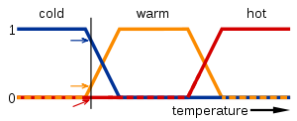](http://en.wikipedia.org/wiki/File:Fuzzy_logic_temperature_en.svg)

**Fig.5.1 Applying truth values for temperature measurement**

**Fuzzy logic temperature**

In this image, the meanings of the expressions *cold*, *warm*, and *hot* are represented by functions mapping a temperature scale. A point on that scale has three "truth values"—one for each of the three functions. The vertical line in the image represents a particular temperature that the three arrows (truth values) gauge. Since the red arrow points to zero, this temperature may be interpreted as "not hot". The orange arrow (pointing at 0.2) may describe it as "slightly warm" and the blue arrow (pointing at 0.8) "fairly cold".

**5.6 Linguistic variables**

While variables in mathematics usually take numerical values, in fuzzy logic applications, the non-numeric *linguistic variables* are often used to facilitate the expression of rules and facts.

A linguistic variable such as *age* may have a value such as *young* or its antonym *old*. However, the great utility of linguistic variables is that they can be modified via linguistic hedges applied to primary terms. The linguistic hedges can be associated with certain functions.

**5.7 Fuzzification and Fuzzy set**

The process of converting crisp quantity to fuzzy quantity is called fuzzification. The addition of [fuzziness](http://en.wiktionary.org/wiki/fuzziness) to [data](http://en.wiktionary.org/wiki/data) in [fuzzy logic](http://en.wiktionary.org/wiki/fuzzy_logic) is fuzzification.

Fuzzy sets are [sets](http://en.wikipedia.org/wiki/Set_(mathematics)) whose [elements](http://en.wikipedia.org/wiki/Element_(mathematics)) have degrees of membership. Fuzzy sets were introduced by [Lotfi A. Zadeh](http://en.wikipedia.org/wiki/Lotfi_Asker_Zadeh" \o "Lotfi Asker Zadeh) and Dieter Klauain 1965 as an extension of the classical notion of set. At the same time, Salii (1965) defined a more general kind of structures called *L*-relations, which were studied by him in an abstract algebraic context. Fuzzy relations, which are used now in different areas, such as [linguistics](http://en.wikipedia.org/wiki/Linguistics) (De Cock, et al, 2000), [decision-making](http://en.wikipedia.org/wiki/Decision_making) (Kuzmin, 1982) and [clustering](http://en.wikipedia.org/wiki/Clustering) (Bezdek, 1978), are special cases of *L*-relations when *L* is the [unit interval](http://en.wikipedia.org/wiki/Unit_interval) [0, 1].

In classical [set theory](http://en.wikipedia.org/wiki/Set_theory), the membership of elements in a set is assessed in binary terms according to a [bivalent condition](http://en.wikipedia.org/wiki/Principle_of_bivalence) — an element either belongs or does not belong to the set. By contrast, fuzzy set theory permits the gradual assessment of the membership of elements in a set; this is described with the aid of a [membership function](http://en.wikipedia.org/wiki/Membership_function_(mathematics)) valued in the real unit interval [0, 1]. Fuzzy sets generalize classical sets, since the [indicator functions](http://en.wikipedia.org/wiki/Indicator_function) of classical sets are special cases of the membership functions of fuzzy sets, if the latter only take values 0 or 1. In fuzzy set theory, classical bivalent sets are usually called [*crisp* sets](http://en.wikipedia.org/wiki/Crisp_set). The fuzzy set theory can be used in a wide range of domains in which information is incomplete or imprecise, such as [bioinformatics](http://en.wikipedia.org/wiki/Bioinformatics).

**Definition**

A fuzzy set is a pair (U, m) where U is a set and m\colon U \rightarrow [0,1].

For each x\in U, the value m(x) is called the grade of membership of x in (U,m). For a finite set U=\{x_1,\dots,x_n\}, the fuzzy set (U, m) is often denoted by \{m(x_1)/x_1,\dots,m(x_n)/x_n\}.

Let x \in U. Then x is called not included in the fuzzy set (U,m) if m(x) = 0, x is called fully included if m(x) = 1, and x is called a fuzzy member if 0 < m(x) < 1. The set \{x\in U\mid m(x)>0\} is called the support of (U,m) and the set \{x\in U\mid m(x)=1\} is called its kernel. The function m is called the membership function of the fuzzy set (U, m).

Sometimes, more general variants of the notion of fuzzy set are used, with membership functions taking values in a (fixed or variable) [algebra](http://en.wikipedia.org/wiki/Algebraic_structure) or [structure](http://en.wikipedia.org/wiki/Structure_(mathematical_logic)) L of a given kind; usually it is required that L be at least a [poset](http://en.wikipedia.org/wiki/Poset" \o "Poset) or [lattice](http://en.wikipedia.org/wiki/Lattice_(order)). These are usually called *L*-fuzzy sets, to distinguish them from those valued over the unit interval. The usual membership functions with values in [0, 1] are then called [0, 1]-valued membership functions. These kinds of generalizations were first considered in 1967 by [Joseph Goguen](http://en.wikipedia.org/wiki/Joseph_Goguen), who was a student of Zadeh.

**5.8 Membership function of a fuzzy set**

The membership function of a [fuzzy set](http://en.wikipedia.org/wiki/Fuzzy_set) is a generalization of the [indicator function](http://en.wikipedia.org/wiki/Indicator_function) in classical [sets](http://en.wikipedia.org/wiki/Set_(mathematics)). In [fuzzy logic](http://en.wikipedia.org/wiki/Fuzzy_logic), it represents the [degree of truth](http://en.wikipedia.org/wiki/Degree_of_truth) as an extension of [valuation](http://en.wikipedia.org/wiki/Valuation_(logic)). Degrees of truth are often confused with [probabilities](http://en.wikipedia.org/wiki/Probability), although they are conceptually distinct, because fuzzy truth represents membership in vaguely defined sets, not likelihood of some event or condition. Membership functions were introduced by [Zadeh](http://en.wikipedia.org/wiki/Lotfi_Asker_Zadeh" \o "Lotfi Asker Zadeh) in the first paper on fuzzy sets (1965).

**Definition**

For any setX, a membership function on X is any function from X to the real unit interval[0,1].

Membership functions on X represent [fuzzy subsets](http://en.wikipedia.org/wiki/Fuzzy_set) ofX. The membership function which represents a fuzzy set \tilde A is usually denoted by \mu_A. For an element x of X, the value\mu_A(x) is called the *membership degree* of x in the fuzzy set \tilde A. The membership degree \mu_{A}(x) quantifies the grade of membership of the element x to the fuzzy set \tilde A. The value 0 means that x is not a member of the fuzzy set; the value 1 means that x is fully a member of the fuzzy set. The values between 0 and 1 characterize fuzzy members, which belong to the fuzzy set only partially.

Sometimes, a more general definition is used, where membership functions take values in an arbitrary fixed algebra or structure L; usually it is required that L be at least a[poset](http://en.wikipedia.org/wiki/Poset) or [lattice](http://en.wikipedia.org/wiki/Lattice_(order)). The usual membership functions with values in [0, 1] are then called [0, 1]- valued membership functions.

[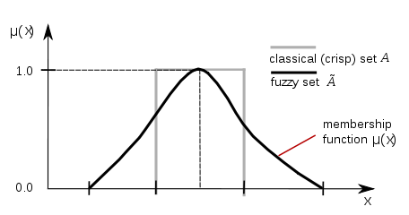](http://en.wikipedia.org/wiki/File:Fuzzy_crisp.svg)

**Fig.5.2 Membership functions of fuzzy**

**5.9 Defuzzification**

The process of converting fuzzy quantity to crisp quantity is defuzzification. Defuzzification is the process of producing a quantifiable result in [fuzzy logic](http://en.wikipedia.org/wiki/Fuzzy_logic), given fuzzy sets and corresponding membership degrees. It is typically needed in control systems. These will have a number of rules that transform a number of variables into a fuzzy result, that is, the result is described in terms of membership in [fuzzy sets](http://en.wikipedia.org/wiki/Fuzzy_sets). For example, rules designed to decide how much pressure to apply might result in "Decrease Pressure (15%), Maintain Pressure (34%), Increase Pressure (72%)". Defuzzification is interpreting the membership degrees of the fuzzy sets into a specific decision or real value.

The simplest but least useful defuzzification method is to choose the set with the highest membership, in this case, "Increase Pressure" since it has a 72% membership, and ignore the others, and convert this 72% to some number. The problem with this approach is that it loses information. The rules that called for decreasing or maintaining pressure might as well have not been there in this case.

A common and useful defuzzification technique is *center of gravity*. First, the results of the rules must be added together in some way. The most typical fuzzy set membership function has the graph of a [triangle](http://en.wikipedia.org/wiki/Triangle). Now, if this triangle were to be cut in a straight horizontal line somewhere between the top and the bottom, and the top portion were to be removed, the remaining portion forms a [trapezoid](http://en.wikipedia.org/wiki/Trapezoid). The first step of defuzzification typically "chops off" parts of the graphs to form trapezoids (or other shapes if the initial shapes were not triangles). For example, if the output has "Decrease Pressure (15%)", then this triangle will be cut 15% the way up from the bottom. In the most common technique, all of these trapezoids are then superimposed one upon another, forming a single [geometric shape](http://en.wikipedia.org/wiki/Geometric_shape). Then, the [centroid](http://en.wikipedia.org/wiki/Centroid" \o "Centroid) of this shape, called the *fuzzy centroid*, is calculated. The *x* coordinate of the centroid is the defuzzified value.

**5.9.1 Methods of defuzzification**

There are many different methods of defuzzification available, including the following:

* AI (adaptive integration)
* BADD (basic defuzzification distributions)
* CDD (constraint decision defuzzification)
* COA (center of area)
* COG (center of gravity)
* ECOA (extended center of area)
* EQM (extended quality method)
* FCD (fuzzy clustering defuzzification)
* FM (fuzzy mean)
* FOM (first of maximum)
* GLSD (generalized level set defuzzification)
* ICOG (indexed center of gravity)
* IV (influence value)
* LOM (last of maximum)
* MeOM (mean of maxima)
* MOM (middle of maximum)
* QM (quality method)
* RCOM (random choice of maximum)
* SLIDE (semi-linear defuzzification)
* WFM (weighted fuzzy mean)

The maxima methods are good candidates for fuzzy reasoning systems. The distribution methods and the area methods exhibit the property of continuity that makes them suitable for fuzzy controllers.

**5.10 Fuzzy Inference**

Fuzzy inference is the process of formulating the mapping from a given input to an output using fuzzy logic. The mapping then provides a basis from which decisions can be made, or patterns discerned. The process of fuzzy inference involves all of the pieces that are described in [Membership Functions](http://www.mathworks.in/help/fuzzy/foundations-of-fuzzy-logic.html#bp78l70-2), [Logical Operations](http://www.mathworks.in/help/fuzzy/foundations-of-fuzzy-logic.html#bp78l70-5), and [If-Then Rules](http://www.mathworks.in/help/fuzzy/foundations-of-fuzzy-logic.html#bp78l70-7).

This section describes the fuzzy inference process and uses the example of the two-input, one-output, three-rule tipping problem [The Basic Tipping Problem](http://www.mathworks.in/help/fuzzy/an-introductory-example-fuzzy-versus-nonfuzzy-logic.html#bq3s7pl) that you saw in the introduction in more detail. The basic structure of this example is shown in the diagram fig.5.3

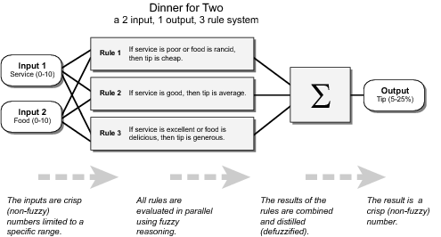

**Fig.5.3 Basic structure of Fuzzy Inference**

l Information flows from left to right, from two inputs to a single output. The parallel nature of the rules is one of the more important aspects of fuzzy logic systems. Instead of sharp switching between modes based on breakpoints, logic flows smoothly from regions where the system's behavior is dominated by either one rule or another.

Fuzzy inference process comprises of five parts:

* [Fuzzification of the input variables](http://www.mathworks.in/help/fuzzy/fuzzy-inference-process.html#FP346)
* [Application of the fuzzy operator (AND or OR) in the antecedent](http://www.mathworks.in/help/fuzzy/fuzzy-inference-process.html#FP347)
* [Implication from the antecedent to the consequent](http://www.mathworks.in/help/fuzzy/fuzzy-inference-process.html#FP348)
* [Aggregation of the consequents across the rules](http://www.mathworks.in/help/fuzzy/fuzzy-inference-process.html#a1054218661b1)
* [Defuzzification](http://www.mathworks.in/help/fuzzy/fuzzy-inference-process.html#a1054218744b1)

A [fuzzy inference diagram](http://www.mathworks.in/help/fuzzy/fuzzy-inference-process.html#FP350) displays all parts of the fuzzy inference process — from fuzzification through defuzzification.

### Step1. Fuzzify Inputs

The first step is to take the inputs and determine the degree to which they belong to each of the appropriate fuzzy sets via membership functions. In Fuzzy Logic Toolbox software, the input is always a crisp numerical value limited to the universe of discourse of the input variable (in this case the interval between 0 and 10) and the output is a fuzzy degree of membership in the qualifying linguistic set (always the interval between 0 and 1). Fuzzification of the input amounts to either a table lookup or a function evaluation.

This example is built on three rules, and each of the rules depends on resolving the inputs into a number of different fuzzy linguistic sets: service is poor, service is good, food is rancid, food is delicious, and so on. Before the rules can be evaluated, the inputs must be fuzzified according to each of these linguistic sets. For example, to what extent is the food really delicious? The following figure shows how well the food at the hypothetical restaurant (rated on a scale of 0 to 10) qualifies, (via its membership function), as the linguistic variable delicious. In this case, we rated the food as an 8, which, given your graphical definition of delicious, corresponds to µ = 0.7 for the delicious membership function.

In this manner, each input is fuzzified over all the qualifying membership functions required by the rules.

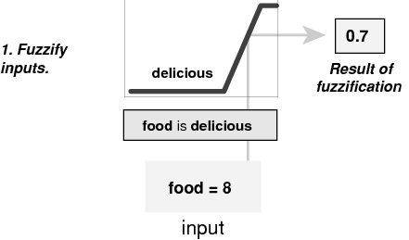

**Fig.5.4 Fuzzification of inputs**

### Step 2. Apply Fuzzy Operator

After the inputs are fuzzified, you know the degree to which each part of the antecedent is satisfied for each rule. If the antecedent of a given rule has more than one part, the fuzzy operator is applied to obtain one number that represents the result of the antecedent for that rule. This number is then applied to the output function. The input to the fuzzy operator is two or more membership values from fuzzified input variables. The output is a single truth value.

As is described in [Logical Operations](http://www.mathworks.in/help/fuzzy/foundations-of-fuzzy-logic.html#bp78l70-5) section, any number of well-defined methods can fill in for the AND operation or the OR operation. In the toolbox, two built-in AND methods are supported: min (minimum) and prod (product). Two built-in OR methods are also supported: max (maximum), and the probabilistic OR method probor. The probabilistic OR method (also known as the algebraic sum) is calculated according to the equation

probor(a,b) = a + b – ab

In addition to these built-in methods, you can create your own methods for AND and OR by writing any function and setting that to be your method of choice.

The following figure shows the OR operator max at work, evaluating the antecedent of the rule 3 for the tipping calculation. The two different pieces of the antecedent (service is excellent and food is delicious) yielded the fuzzy membership values 0.0 and 0.7 respectively. The fuzzy OR operator simply selects the maximum of the two values, 0.7, and the fuzzy operation for rule 3 is complete. The probabilistic OR method would still result in 0.7.

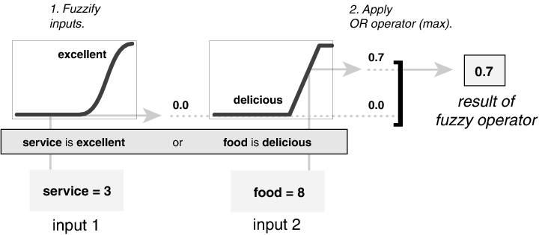

### Fig.5.5 Application of Fuzzy operator to the inputs

### Step 3. Apply Implication Method

Before applying the implication method, you must determine the rule's weight. Every rule has a weight (a number between 0 and 1), which is applied to the number given by the antecedent. Generally, this weight is 1 (as it is for this example) and thus has no effect at all on the implication process. From time to time you may want to weight one rule relative to the others by changing its weight value to something other than 1.

After proper weighting has been assigned to each rule, the implication method is implemented. A consequent is a fuzzy set represented by a membership function, which weights appropriately the linguistic characteristics that are attributed to it. The consequent is reshaped using a function associated with the antecedent (a single number). The input for the implication process is a single number given by the antecedent, and the output is a fuzzy set. Implication is implemented for each rule. Two built-in methods are supported, and they are the same functions that are used by the AND method: min (minimum), which truncates the output fuzzy set, and prod (product), which scales the output fuzzy set.

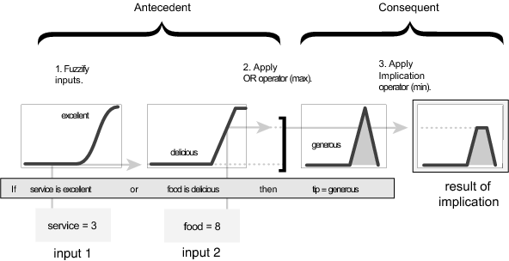

**Fig.5.6 Implication method**

### Step 4. Aggregate All Outputs

Because decisions are based on the testing of all of the rules in a FIS, the rules must be combined in some manner in order to make a decision. Aggregation is the process by which the fuzzy sets that represent the outputs of each rule are combined into a single fuzzy set. Aggregation only occurs once for each output variable, just prior to the fifth and final step, defuzzification. The input of the aggregation process is the list of truncated output functions returned by the implication process for each rule. The output of the aggregation process is one fuzzy set for each output variable.

As long as the aggregation method is commutative (which it always should be), then the order in which the rules are executed is unimportant. Three built-in methods are supported:

* max (maximum)
* probor (probabilistic OR)
* sum (simply the sum of each rule's output set)

In the following diagram, all three rules have been placed together to show how the output of each rule is combined, or aggregated, into a single fuzzy set whose membership function assigns a weighting for every output (tip) value.

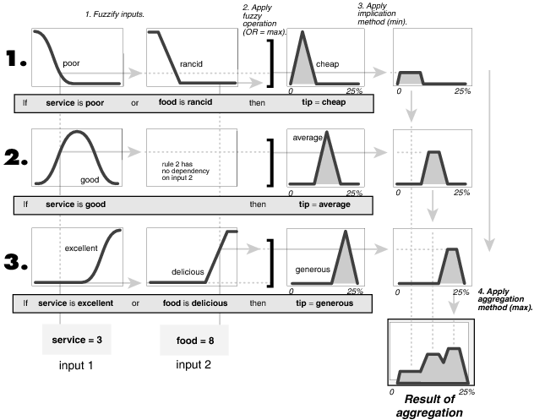

**Fig.5.7 Aggregation of outputs of fuzzy**

### 

### Step 5. Defuzzify

The input for the defuzzification process is a fuzzy set (the aggregate output fuzzy set) and the output is a single number. As much as fuzziness helps the rule evaluation during the intermediate steps, the final desired output for each variable is generally a single number. However, the aggregate of a fuzzy set encompasses a range of output values, and so must be defuzzified in order to resolve a single output value from the set.

Perhaps the most popular defuzzification method is the centroid calculation, which returns the center of area under the curve. There are five built-in methods supported: centroid, bisector, middle of maximum (the average of the maximum value of the output set), largest of maximum, and smallest ofmaximum.

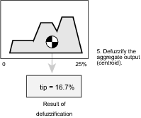

**Fig.5.8 Defuzzifying the outputs**

### 5.10.1 Explaination of Fuzzy Inference Diagram

The fuzzy inference diagram is the composite of all the smaller diagrams presented so far in this section. It simultaneously displays all parts of the fuzzy inference process you have examined. Information flows through the fuzzy inference diagram as shown in the figure 5.8.

In this figure, the flow proceeds up from the inputs in the lower left, then across each row, or rule, and then down the rule outputs to finish in the lower right. This compact flow shows everything at once, from linguistic variable fuzzification all the way through defuzzification of the aggregate output.

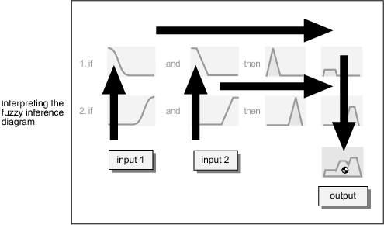

**Fig.5.9 Fuzzy Inference diagram**

For instance, from this diagram with these particular inputs, you can easily see that the implication method is truncation with the min function. The max function is being used for the fuzzy OR operation. Rule 3 (the bottom-most row in the diagram shown previously) is having the strongest influence on the output. and so on.

The Rule Viewer described in [The Rule Viewer](http://www.mathworks.in/help/fuzzy/building-systems-with-fuzzy-logic-toolbox-software.html#FP484) is a MATLABimplementation of the fuzzy inference diagram.

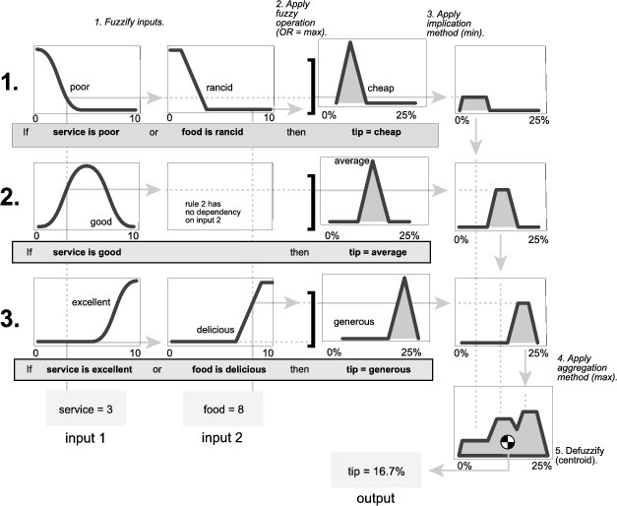

**Fig.5.10. Actual full-size fuzzy inference diagram**

**5.11 Building a Fuzzy Inference System**

Fuzzy inference is a method that interprets the values in the input vector and, based on user defined rules, assigns values to the output vector. Using the GUI editors and viewers in the Fuzzy Logic Toolbox, you can build the rules set, define the membership functions, and analyze the behavior of a fuzzy inference system (FIS). The following editors and viewers are provided.

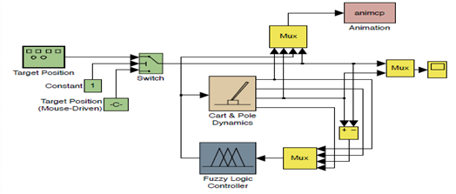

**Fig.5.11 Fuzzy Interference System basic block diagram**

**Key Features**

* Specialized GUIs for building fuzzy inference systems and viewing and analyzing results
* Membership functions for creating fuzzy inference systems
* Support for AND, OR, and NOT logic in user-defined rules
* Standard Mandeni and Surgeons-type fuzzy inference systems
* Automated membership function shaping through neuro adaptive and fuzzy clustering learning techniques
* Ability to embed a fuzzy inference system in a Simulink model
* Ability to generate embeddable C code or stand-alone executable fuzzy inference engines.

In this section we'll be building a simple tipping example using the graphical user interface (GUI) tools provided by the Fuzzy Logic Toolbox. Although it's possible to use the Fuzzy Logic Toolbox by working strictly from the command line, in general it's much easier to build a system graphically. There are five primary GUI tools for building, editing, and observing fuzzy inference systems in the Fuzzy Logic Toolbox. The Fuzzy Inference System or FIS Editor, the Membership Function Editor, the Rule Editor, the Rule Viewer, and the Surface Viewer. These GUIs are dynamically linked, in that changes you make to the FIS using one of them, can affect what you see on any of the other open GUIs. You can have any or all of them open for any given system.

**5.12 Types of Fuzzy Logic Tool Box**

The FIS Editor handles the high level issues for the system: How many input and output variables? What are their names? The Fuzzy Logic Toolbox doesn't limit the number of inputs. However, the number of inputs may be limited by the available memory of your machine. If the number of inputs is too large, or the number of membership functions is too big, then it may also be difficult to analyze the FIS using the other GUI tools. The Membership Function Editor is used to define the shapes of all the membership functions associated with each variable. The Rule Editor is for editing the list of rules that defines the behavior of the system.

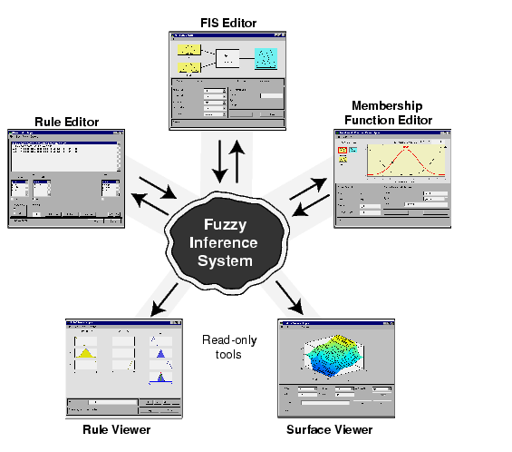

**Fig.5.12 The Primary GUI Tools of the Fuzzy Logic Toolbox**

The Rule Viewer and the Surface Viewer are used for looking at, as opposed to editing, the FIS. They are strictly read-only tools. The Rule Viewer is a Matlab-based display of the fuzzy inference diagram shown at the end of the last section. Used as a diagnostic, it can show (for example) which rules are active, or how individual membership function shapes are influencing the results. The Surface Viewer is used to display the dependency of one of the outputs on any one or two of the inputs that is, it generates and plots an output surface map for the system.

The starting point is to write down the three golden rules of tipping, based on years of personal experience in restaurants.

1. If the service is poor or the food is rancid, then tip is cheap.

2. If the service is good, then tip is average.

3. If the service is excellent or the food is delicious, then tip is generous.

**5.12.1 The FIS Editor**

The following discussion walks you through building a new fuzzy inference system from scratch. If you want to save time and follow along quickly, you can load the already built system by typing fuzzy tipper this will load the FIS associated with the file tipper.fis (the FIS is implied) and launch the FIS Editor. However, if you load the pre-built system, you will not be building rules and constructing membership functions. The FIS Editor displays general information about a fuzzy inference system. There's a simple that shows the names of each input variable on the left, and those of each output variable on the right.

The sample membership functions shown in the boxes are just icons and do not depict the actual shapes of the membership functions.

Below the diagram is the name of the system and the type of inference used. The default, Madman-type inference, is what we'll continue to use for this example. Another slightly different type of inference, called Surgeon-type inference, is also available. Below the name of the fuzzy inference system, on the left side of the figure, are the pop-up menus that allow you to modify the various pieces of the inference process. On the right side at the bottom of the figure is the area that displays the name of an input or output variable, its associated membership function type, and its range.

We'd like to change the variable names to reflect that, though:

* Click once on the left-hand (yellow) box marked input1 (the box will be highlighted in red).
* In the white edit field on the right, change input1 to service and press Return.
* Click once on the left-hand (yellow) box marked **i**nput2 (the box will be highlighted in red).
* In the white edit field on the right, change input2 to food and press Return.
* Click once on the right-hand (blue) box marked output1.
* In the white edit field on the right, change output1 to tip.

**5.12.2 The Membership Function Editor**

The Membership Function Editor shares some features with the FIS Editor. In fact, all of the five basic GUI tools have similar menu options, status lines, and Help and Close buttons. The Membership Function Editor is the tool that lets you display and edit all of the membership functions associated with all of the input and output variables for the entire fuzzy inference system shows the Membership Function Editor.

On the upper left side of the graph area in the Membership Function Editor is a "Variable Palette" that lets you set the membership functions for a given variable. To set up your membership functions associated with an input or an output variable for the FIS, select an FIS variable in this region by clicking on it .Next select the Edit pull-down menu, and choose Add MFs.... A new window will appear which allows you to select both the membership function type and the number of membership functions associated with the selected variable. In the lower right corner of the window are the controls that let you change the name, type, and parameters (shape), of the membership function, once it has been selected.

Use the pull-down tab to choose gauss mf for MF Type and 3 for Number of MFs. This adds three Gaussian curves to the input variable service. Click once on the curve with the leftmost hump. Change the name of the curve to poor. To adjust the shape of the membership function, either use the mouse, as described above, or type in a desired parameter change, and then click on the membership function.

Select Add MFs... from the Edit menu and add two tramps curves to the input variable food. Click once directly on the curve with the leftmost trapezoid. Change the name of the curve to rancid. To adjust the shape of the membership function, either use the mouse, as described above, or type in a desired parameter change, and then click on the membership function. The default parameter listing for this curve is [0 0 1 3]. Name the curve with the rightmost trapezoid, delicious, and reset the associated parameters if desired. Now that the variables have been named, and the membership functions have appropriate shapes and names, you're ready to write down the rules. To call up the Rule Editor, go to the View menu and select Edit rules..., or type rule edit at the command line.

-1 -0.66 -0.33 0 0.33 0.66 1

NB NM NS 1

ZE PS PM PB

**Fig.5.13 The membership functions for inputs E and CE**

**5.12.3 The Rule Editor**

Constructing rules using the graphical Rule Editor interface is fairly self-evident. Based on the descriptions of the input and output variables defined with the FIS Editor, the Rule Editor allows you to construct the rule statements automatically, by clicking on and selecting one item in each input variable box, one item in each output box, and one connection item. Choosing none as one of the variable qualities will exclude that variable from a given rule. Choosing not under any variable name will negate the associated quality. Rules may be changed, deleted, or added, by clicking on the appropriate button. The Rule Editor also has some familiar landmarks, similar to those in the FIS Editor and the Membership Function Editor, including the menu bar and the status line. The Format pop-up menu is available from the Options pull-down menu from the top menu bar -- this is used to set the format for the display. Similarly, Language can be set from under Options as well. The Help button will bring up a MATLAB Help window.

The Rule Editor

1. To insert the first rule in the Rule Editor, select the following:
2. Poor under the variable service
3. Rancid under the variable food
4. The radio button, or, in the Connection block
5. Cheap, under the output variable, tip.

The resulting rule is

1. If (service is poor) or (food is rancid) then (tip is cheap) (1). The numbers in the parentheses represent weights that can be applied to each rule if desired. You can specify the weights by typing in a desired number between zero and one under the Weight setting. If you do not specify them, the weights are assumed to be unity (1).

Follow a similar procedure to insert the second and third rules in the Rule Editor to get

1. If (service is poor) or (food is rancid) then (tip is cheap) (1)

2. If (service is good) then (tip is average) (1)

3. If (service is excellent) or (food is delicious) then (tip is generous) (1)

To change a rule, first click on the rule to be changed. Next make the desired changes to that rule, and then click on Change rule. For example, to change the first rule to

1. If (service not poor) or (food not rancid) then (tip is not cheap) (1)

Click not under each variable, and then click Change rule.

The Format pop-up menu from the Options menu indicates that you're looking at the verbose form of the rules. Try changing it to symbolic. You will see

1. (Service==poor) => (tip=cheap) (1)

2. (Service==good) => (tip=average) (1)

3. (Service==excellent) => (tip=generous) (1)

**5.12.4 The Rule Viewer**

The Rule Viewer displays a roadmap of the whole fuzzy inference process. It's based on the fuzzy inference diagram described in the previous section. You see a single figure window with 10 small plots nested in it. The three small plots across the top of the figure represent the antecedent and consequent of the first rule. Each rule is a row of plots, and each column is a variable.

The Rule Viewer allows you to interpret the entire fuzzy inference process at once. The Rule Viewer also shows how the shape of certain membership functions influences the overall result. Since it plots every part of every rule, it can become unwieldy for particularly large systems, but, for a relatively small number of inputs and outputs, it performs well (depending on how much screen space you devote to it) with up to 30 rules and as many as 6 or 7 variables. The Rule Viewer shows one calculation at a time and in great detail. In this sense, it presents a sort of micro view of the fuzzy inference system. If you want to see the entire output surface of your system, that is, the entire span of the output set based on the entire span of the input set, you need to open up the Surface Viewer. This is the last of our five basic GUI tools in the Fuzzy Logic Toolbox, and you open it by selecting View surface... from the View menu.

**6. BLOCK DIAGRAM OF SYSTEM**

The system performance can be explained using this block diagram.



**Fig.6.1 Block diagram of the system**

The system consists of appliances in a house such as television set, computer, washing machine, dryer, dish washer and a control system. The control system is able to communicate with all the appliances in an apartment. It monitors the functioning of each device and it can supervise that how much time an appliance should operate and how much amount of energy should it consume and when they should be switched on or off.

The main duty of control system is to maintain the consumption of energy below the specified maximum demand value at peak hours. So in view of this the control system is capable of giving some basic commands such as hold, continue which influences the operation of appliances. The hold command forces the appliance to switch to standby mode where its energy consumption is less when compared to its usage when it is switched on. The continue command switches on the appliance and the appliance resumes its task. The control system decides which appliance should be hold or continue its operation based on maximum energy consumption.

During the period of demand peak hours the control system evaluates the total consumption of all the devices which are working. If the total consumption does not exceed the maximum limit then it does not interrupt the operation of any of the devices. In case if the total consumption of all the devices exceed the specified maximum limit then it evaluates the system that if there are any low priority devices are ON. If there are any low priority devices in ON state then it sends a hold command to such devices and they resume their operation. The controller sequentially sends hold command to the low priority devices and evaluates the system that the total consumption does not exceed the maximum limit. During each interval of sending commands to low priority devices it evaluates the system total consumption of energy. The controller continues to do this process until total consumption of energy of all devices falls below the maximum demand.

After resuming the operation of all the low priority devices and still the total consumption of energy exceeds the maximum limit then the controller goes for resuming the operation of any of the high priority devices based on queuing operation until the total energy consumption falls below the specified maximum limit.

**7.SIMULATION RESULTS**

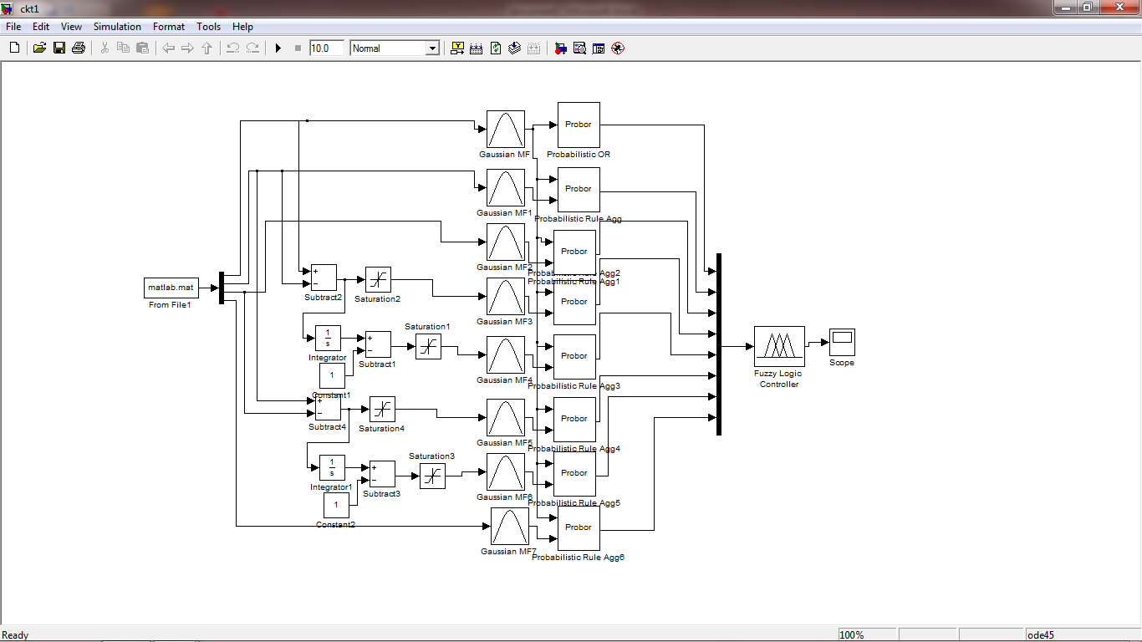

**Fig.7.1 Simulation diagram**

**Examples of Fuzzy Rules**

1. If (change\_in\_demand is PS) and (maximum\_demand is PL) and (difference is PL) then (computer is PROLONG)(airconditioner is PROLONG)(hair\_drier is CONTINUE)(washing\_machine is CONTINUE) (1)

2. If (change\_in\_demand is PM) and (maximum\_demand is PL) and (difference is PM) then (computer is CONTINUE)(airconditioner is CONTINUE)(hair\_drier is CONTINUE)(washing\_machine is CONTINUE) (1)

3. If (change\_in\_demand is PL) and (maximum\_demand is PL) and (difference is NS) then (computer is CONTINUE)(airconditioner is CONTINUE)(hair\_drier is HOLD)(washing\_machine is CONTINUE) (1)

4. If (change\_in\_demand is NS) and (maximum\_demand is PL) and (difference is PL) then (computer is PROLONG)(airconditioner is PROLONG)(hair\_drier is CONTINUE)(washing\_machine is CONTINUE) (1)

5. If (change\_in\_demand is NM) and (maximum\_demand is PL) and (difference is PL) then (computer is PROLONG)(airconditioner is PROLONG)(hair\_drier is CONTINUE)(washing\_machine is CONTINUE) (1)

6. If (change\_in\_demand is NL) and (maximum\_demand is PL) and (difference is PL) then (computer is PROLONG)(airconditioner is PROLONG)(hair\_drier is CONTINUE)(washing\_machine is CONTINUE) (1)

7. If (change\_in\_demand is PS) and (maximum\_demand is PM) and (difference is PS) then (computer is CONTINUE)(airconditioner is CONTINUE)(hair\_drier is CONTINUE)(washing\_machine is CONTINUE) (1)

8. If (change\_in\_demand is PM) and (maximum\_demand is PM) and (difference is PS) then (computer is CONTINUE)(airconditioner is CONTINUE)(hair\_drier is CONTINUE)(washing\_machine is CONTINUE) (1)

9. If (change\_in\_demand is PL) and (maximum\_demand is PM) and (difference is NS) then (computer is CONTINUE)(airconditioner is CONTINUE)(hair\_drier is CONTINUE)(washing\_machine is HOLD) (1)

10. If (change\_in\_demand is NS) and (maximum\_demand is PM) and (difference is PM) then (computer is CONTINUE)(airconditioner is CONTINUE)(hair\_drier is CONTINUE)(washing\_machine is CONTINUE) (1)

11. If (change\_in\_demand is NM) and (maximum\_demand is PM) and (difference is PL) then (computer is PROLONG)(airconditioner is PROLONG)(hair\_drier is CONTINUE)(washing\_machine is CONTINUE) (1)

12. If (change\_in\_demand is NL) and (maximum\_demand is PM) and (difference is PL) then (computer is PROLONG)(airconditioner is PROLONG)(hair\_drier is CONTINUE)(washing\_machine is CONTINUE) (1)

13. If (change\_in\_demand is PS) and (maximum\_demand is PS) and (difference is PS) then (computer is CONTINUE)(airconditioner is CONTINUE)(hair\_drier is CONTINUE)(washing\_machine is CONTINUE) (1)

14. If (change\_in\_demand is PM) and (maximum\_demand is PS) and (difference is NM) then (computer is CONTINUE)(airconditioner is CONTINUE)(hair\_drier is CONTINUE)(washing\_machine is HOLD) (1)

15. If (change\_in\_demand is PL) and (maximum\_demand is PS) and (difference is NL) then (computer is CONTINUE)(airconditioner is CONTINUE)(hair\_drier is HOLD)(washing\_machine is HOLD) (1)

16. If (change\_in\_demand is NS) and (maximum\_demand is PS) and (difference is PS) then (computer is CONTINUE)(airconditioner is CONTINUE)(hair\_drier is CONTINUE)(washing\_machine is CONTINUE) (1)

17. If (change\_in\_demand is NM) and (maximum\_demand is PS) and (difference is PM) then (computer is CONTINUE)(airconditioner is CONTINUE)(hair\_drier is CONTINUE)(washing\_machine is CONTINUE) (1)

18. If (change\_in\_demand is NL) and (maximum\_demand is PS) and (difference is PL) then (computer is CONTINUE)(airconditioner is CONTINUE)(hair\_drier is CONTINUE)(washing\_machine is CONTINUE) (1)

19. If (change\_in\_demand is PL) and (maximum\_demand is NS) and (difference is NL) then (computer is CONTINUE)(airconditioner is CONTINUE)(hair\_drier is HOLD)(washing\_machine is HOLD) (1)

20. If (change\_in\_demand is PM) and (maximum\_demand is NS) and (difference is NM) then (computer is CONTINUE)(airconditioner is CONTINUE)(hair\_drier is HOLD)(washing\_machine is HOLD) (1)

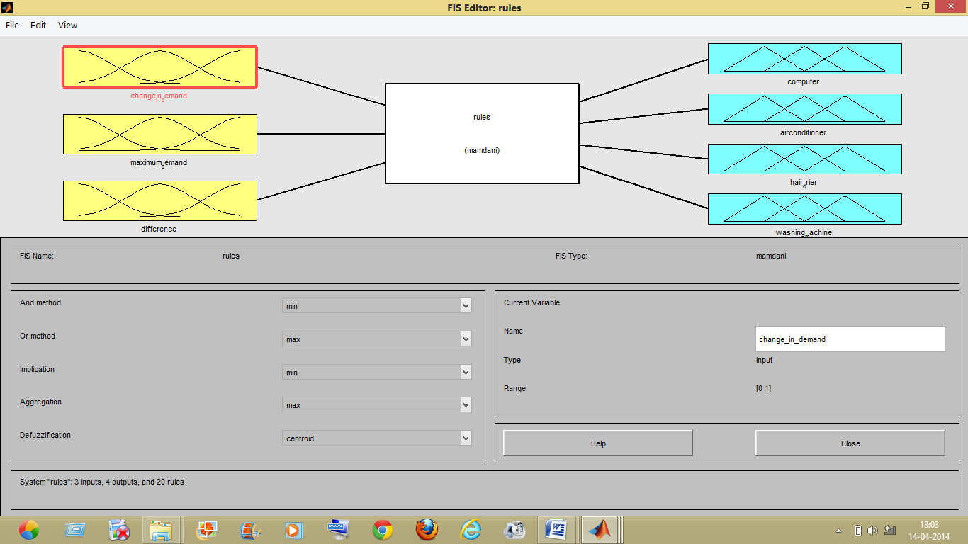

**Fig.7.2 FIS editor**

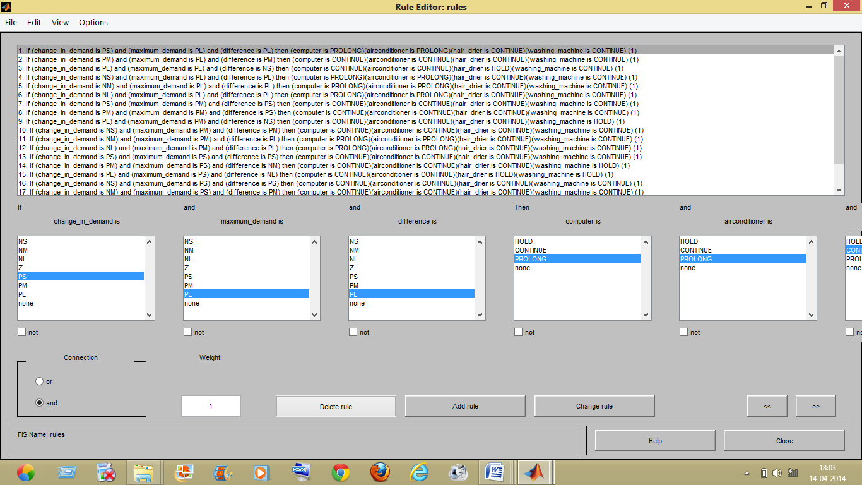

**Fig.7.3 Rule editor**

**Simulation data**

The simulation data taken as inputs is extracted from a paper presented by **P. Ravi Babu** and **V.Sree Divya** titled Application of ANN and DSM Techniques for peak load management. Load data for period of one day is collected from the industry Kurnool District Milk Producers Cooperative Union limited, Nandi milk & milk products, Nandyal.

|  |  |  |  |
| --- | --- | --- | --- |
| Change in demand | Maximum demand | Change in demand | Maximum demand |
| 412.6 | 500 | 322.8 | 500 |
| 410.4 | 500 | 286.7 | 500 |
| 432.0 | 500 | 273.3 | 500 |
| 403.5 | 500 | 311.4 | 500 |
| 445.3 | 500 | 337.0 | 500 |
| 426.8 | 500 | 363.4 | 500 |
| 441.1 | 500 | 461.2 | 500 |
| 401.9 | 500 | 424.3 | 500 |
| 336.6 | 500 | 431.9 | 500 |
| 341.5 | 500 | 410.9 | 500 |
| 329.3 | 500 | 398.8 | 500 |
| 314.5 | 500 | 410.0 | 500 |

**Table.7.1 Simulation data**

**Results**

**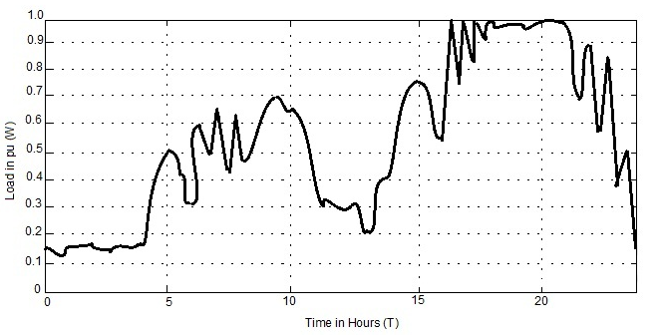Fig.7.4 Load curve of the day without Fuzzy Logic Controller**

During off peak hours without the use of fuzzy logic controller the demand reaches the maximum limit as shown in the figure 7.2 .So As time proceeds the demand may exceed the specified maximum limit which may force the consumer to search for other alternative sources of energy.

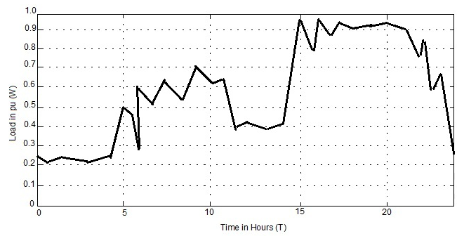

**Fig.7.5 Load curve of the day with Fuzzy Logic Controller**

With the effective management of home appliances with the use of Fuzzy logic controller the load demand does not exceed the maximum specified limit as during peak hours shown in figure 7.3

**8. CONCLUSION**

Using Fuzzy logic controller we can reduce the consumption of energy at load side by managing the consumption of electricity of appliances. Demand side management plays a significant role in saving the customer bill and prevents the consumer to switch to other sources of energy during peak demand hours.

When input data is given to the fuzzy logic controller with the help of from file block it evaluates the system such that the energy consumption does not exceed the maximum specified limit by controlling the energy consumption of appliances according to their prioritized classes. Fuzzy logic controller helps us to build linguistic variables so that we can rebuild system and helps in reconstruction with slight modification of present system.

**REFERENCES**

* Georgios Kardaras, Ana Rosselo-Busquet, VillyBaekIversen, Jose Soler, IEEE, “Regulating electricity demand peaks for home appliances using reversible fair scheduling”, 978-1-4244-7932-0/10/$26.00, 2010-IEEE
* Venkat Natrajan,IEEE, “Demand side approaches to manage electricity outages in developing countries”,978-1-4673-1454-1/12/$31.00 ,2012 -IEEE
* P.Govender, A.Ramballe,S.A.Moodley IEEE, “A Load Shedding controller for management of residential loads during peak demand hours”, 0-7083-8605-1/$17.00 ,2004-IEEE
* Young-Do-lim,Seung-Cheol Kim,Jong-Oh Park,Yeon-Gyu Choo,IEEE, “A Predictive demand of the maximum electric power using chaos –fuzzy”,0-7803-7293-X/01/$17.00 2001 IEEE
* P. Ravi Babu and V.Sree Divya ,IEEE, “ Application of ANN and DSM Techniques for peak load management. Load”,978-1-4244-1889-6/08/$25.00 2008 IEEE
* P.Ravi Babu and A. Praveen, IEEE, “An Approach of DSM for Domestic load Management”, 978-1-4244-3597-5/09/$25.00 2009 IEEE